TRAINING AND PLACEMENT CELL
ACADEMIC YEAR 2024-2025
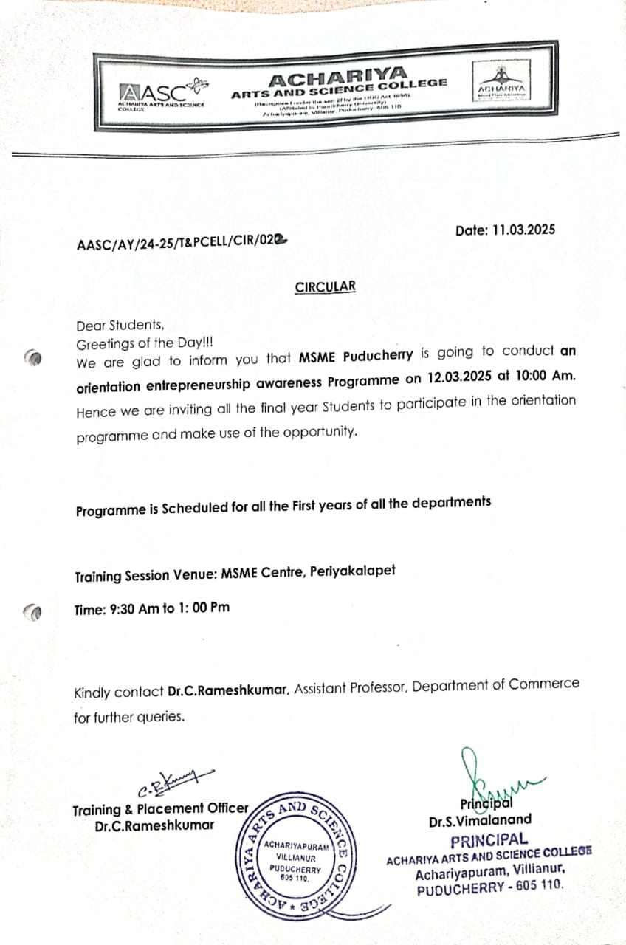
MSME AWARENESS PROGRAMME on 12.03.2025

